**The extinction of species as a result of global warming: how increased metabolic rates upscale to species extinction dynamics**

Bachelorarbeit

Julius-Maximilians-Universität, Würzburg

Fakultät für Chemie und Pharmazie

Studienfach: Biochemie

Vorgelegt von

Lea Li aus Böblingen

Würzburg, 2020

Die vorliegende Arbeit wurde im Zeitraum von 18.05 bis zum 17.08.2020 am Center for Computational and Theoretical Biology (CCTB), in der Arbeitsgruppe Ecosystem Modeling der der Julius-Maximilians-Universität Würzburg unter der Leitung von Prof. Juliano Sarmento Cabral angefertigt.

Table of Contents

Abstract 5

Aim 5

Methods 5

Results 5

Conclusion 6

Zusammenfassung 6

Ziel 6

Methoden 6

Ergebnisse 6

Schlussfolgerung 7

Introduction 7

Extinction of species 7

Extinction of species as a result of global warming 7

Population models 8

Population dynamics 9

Beverton-Holt population model 9

Ricker population model 10

Metapopulation models 10

Species distribution models 11

Dynamic range models 11

Metabolic theory of ecology 12

Stochasticity 13

Demographic Stochasticity 14

Environmental Stochasticity 14

Objectives 15

Methods 15

Model description 15

Purpose 16

State variables and scales 16

Process overview and scheduling 17

Input 18

Initialization 19

Stochasticity 20

Reproduction 21

Metabolic equation 22

Catastrophic mortality function 22

Experimental design 23

Analyses 24

Results 25

Discussion 30

Limitations and Perspectives 31

References 33

Supplementary Material 39

Eigenständigkeitserklärung 41

Keywords: extinction risk, global warming, Metabolic Theory of Ecology, demographic stochasticity, environmental stochasticity, metapopulation dynamics, species distribution models, dynamic range models, Ricker model, Beverton-Holt model

# Abstract

## Aim

One of the greatest threats to global biodiversity is the extinction of species under climate change. Therefore, anticipating species responses to climate change is a crucial global challenge that scientists are currently facing. It is essential to understand whether a species will be able to adapt to the changing climatic conditions within its current habitat and under which conditions species extinction risk will increase. In order to reduce the risk of species extinction with this knowledge if possible.

## Methods

In this study I use a mechanistic niche model that integrates species demography in a both metabolic and stochastic framework. In this context he relationship between species extinction, trait composition and spatial distribution of species will be investigated. Therefore, the Beverton-Holt population model will be applied as deterministic skeleton. In the modelling approach, demographic rates and carrying capacity follow metabolic constraints within the simulated demographic processes such as reproduction, mortality, dispersal and recruitment. The effects of different climate change scenarios on the risk of species extinction will be studied by integrating different global warming scenarios into the simulation. This study examines how hypothetical species with different species-specific traits react to different scenarios of climate change under a metabolic metapopulation framework.

## Results

The results show that the risk of extinction for the different climate change scenarios depends strongly on the species characteristics (e.g. body mass and temperature tolerance). Thereby, risk of extinction increases the more rapidly climate change occurs. Furthermore, it was determined, that larger species are at higher extinction risk, while small species show an increased abundance under climate change scenarios.

## Conclusion

In general, the findings of this study reveal interesting correlations between species-specific traits and various climate change scenarios from a metabolic point of view, as they were expected. Further studies can build on this.

# Zusammenfassung

## Ziel

Eine der größten Bedrohungen für die globale biologische Vielfalt ist das Aussterben von Arten durch den Klimawandel. Daher ist die Vorhersage der Anpassungsfähigkeit und das Risiko des Aussterbens von Arten auf Grund Globaler Erwärmung eine entscheidende Herausforderung, der sich die Wissenschaftler derzeit stellen müssen. Es ist von zentraler Bedeutung zu verstehen, ob eine Art in der Lage sein wird, sich an die sich ändernden klimatischen Bedingungen innerhalb ihres derzeitigen Lebensraums anzupassen, und unter welchen Bedingungen das Risiko des Artensterbens zunimmt. Um mit diesem Wissen nach Möglichkeit das Risiko des Artensterbens zu verringern.

## Methoden

In dieser Studie verwende ich ein mechanistisches Nischenmodell, das die Demographie der Spezies sowohl in einem metabolischen als auch in einem stochastischen Rahmen integriert. In diesem Zusammenhang wird die Beziehung zwischen Artensterben, Merkmalszusammensetzung und räumlicher Verteilung der Arten untersucht. Dazu wird das Beverton-Holt-Populationsmodell als deterministisches Skelett angewendet. In dem Modellierungsansatz folgen demographische Raten und Tragfähigkeit metabolischen Zwängen innerhalb der simulierten demographischen Prozesse wie Reproduktion, Mortalität, Ausbreitung und Rekrutierung. Die Auswirkungen verschiedener Szenarien des Klimawandels auf das Risiko des Artensterbens werden untersucht, indem verschiedene Szenarien der globalen Erwärmung in die Simulation integriert werden. Diese Studie untersucht, wie hypothetische Arten mit verschiedenen artspezifischen Merkmalen auf diverse Szenarien des Klimawandels unter einem metabolischen Metapopulationsrahmen reagieren.

## Ergebnisse

Die Ergebnisse zeigen, dass das Aussterberisiko für die verschiedenen Szenarien des Klimawandels stark von den Arteneigenschaften (z.B. Biomasse und Temperatureigenschaften) abhängt. Dabei nimmt das Aussterberisiko zum einen mit schneller stattfindendem Klimawandel zu. Des weiteren wurde festgestellt, dass größere Arten einem höheren Aussterberisiko ausgesetzt sind, während kleine Arten unter Klimawandel-Szenarien eine erhöhte Abundanz aufweisen.

## Schlussfolgerung

Im Allgemeinen zeigen die Ergebnisse dieser Studie interessante Korrelationen zwischen artspezifischen Merkmalen und verschiedenen Klimawandel-Szenarien aus metabolischer Sicht, wie sie erwartet wurden. Weitere Studien können auf dieser aufbauen.

# Introduction

## Extinction of species

The extinction of species is a natural process that has occurred throughout the Earth's history and is still ongoing (Downing & Leibold*,* 2002). More than 99 percent of all species that have ever existed have become extinct over time due to natural causes such as volcanic eruptions or asteroid impacts (Taylor, 2004; Barnosky *et al.,* 2011). However, extinction rates are dramatically increasing. Nowadays, extinction by human activities is taking place much faster. Due to anthropogenic climate change and because the environment is changed by humans, we are losing species at the fastest rate (Pimm *et al.,*1995; Barnosky *et al.,* 2011). This will have a massive overall impact. Since all species are connected by their interactions in a network of life, the extinction of any species could have serious consequences. If a species has a unique function in its ecosystem, its extinction may trigger catastrophic effects (e.g. in the food chain) that affects other species and the ecosystem itself. Therefore, the extinction of a single species can trigger a cascade of extinctions (Gilbert, 1980). For example, allowed the removal of a starfish that was a top predator in a marine community one mussel species to outcompete and exterminate populations of other species (Paine, 1966). Currently, the extinction of bees is observed. Due to the crucial function of bees as pollinators in ecosystems, this could have serious overall impacts on environment and biodiversity. Thus, it is indispensable to determine the causes that influence extinction risk.

### Extinction of species as a result of global warming

The current impacts of global warming (i.e. increase in temperature) on ecosystems are increasingly recognized. Anthropogenic activities have led to a rapid increase in greenhouse gases e.g. atmospheric carbon dioxide which in turn has resulted in numerous observable climate changes such as higher temperatures (National Research Council, 2010). The global average temperature has already increased by 1°C from preindustrial levels (Scheffers *et al.,* 2016). Understanding the sources and consequences of these shifts will be crucial as we move forward into a warming world. In the next 100 years under conservative climate change scenarios, temperatures are expected to rise by 1.1 to 2.9 °C (Munch & Salinas, 2009). Based on this increase in temperature, ectotherm lifespans may be expected to shorten, resulting in widespread consequences, including higher extinction risks. Global warming over the past decades has produced shifts in species distributions and abundances (Thomas *et al.,* 2004). Thus, global warming has been associated with extinction at species level (Parmesan *et al.,* 2003; Root *et al.,* 2003; Pounds *et al.,* 1999). As the Earth is becoming warmer than at any time (Folland *et al.,* 2001), the species' ability to respond to current and past changes in climate raises the possibility that anthropogenic climate change could become the main cause of species extinction in the near future (Thomas *et al.,* 2004). Furthermore, it is of highest priority to understand such consequences, as the collapse of the insect fauna has been observed in the recent years (Seibold *et al.,* 2019). Thus, it is of great importance to examine the effects of rising temperatures on ecosystems. In this study I therefore aim at quantifying the extinction risk of different bee species under various climate change scenarios. Under climate change, species are expected to shift their ranges (Cabral *et al.,* 2013), which can be defined as a population of several local populations (i.e. a metapopulation) connected by dispersal. Therefore, it is crucial to describe how local population and metapopulation dynamics over the species’ range respond to climate change. Species extinctions may involve local extinction and global extinction which implies the extinction of all local populations – i.e. of the entire metapopulation across species’ range.

## Population models

A population is the amount of all individuals of a species that live in an area and interact with each other. A population has characteristics that are only defined for this number of individuals. This includes the size of the population or the population density (i.e. abundance or number of individuals), the spatial/ geographical location, the age/ stage/ sex structure as well as functional composition (i.e. local values of the individual traits, such as body mass and dispersal ability), including intrapopulation trait heterogeneity. Population ecology aims to describe these traits and their changes in time and space. Models that dynamically describe these characteristics thus aim to determine the population abundance from a certain point in time to a later point in time. Important population processes are the births and deaths within the population. Besides these processes, individual immigration and emigration to and from other populations link populations within a metapopulation dynamics across a species’ range, which will be discussed in more detail in the Metapopulation models section below.

### Population dynamics

It is unlikely that births and deaths in natural populations in a certain time interval always balance each other out exactly. Since the population size fluctuates in the course of time, it is crucial for understanding a population to measure the population size at frequent time intervals.

It is convenient to consider time in generations if considering a species that propagates in discrete time steps (e.g. annual steps). Births and deaths refer to the selected time step. Those parameters depend on the length of the chosen time step, in the simplest case these parameters are constant and are the same for each timestep. Biologically this would mean that the birth and death processes (and thus the birth and death rate parameters) would not be influenced by stochastic factors or other underlying deterministic processes in the population. For example, the absolute expected number of births in a timestep then results from the product of the per capita growth rate and the population size. If the population size is then plotted over time, one gets a graphical impression of the fluctuations in population abundance (population dynamics). Determining the population size or density over a longer period of time results in a time series.

This raises the question of what trends can be expected in a population over time. One differentiates between parameters and variables. Parameters capture the assumptions and hypotheses that may be relevant to the dynamics of the system under consideration. In deterministic models they are usually constants but can turn into variables if they change according to stochasticity or the underlying processes (Shoemaker *et al*., 2020). Variables, on the other hand, are the components of a model whose dynamic behavior is to be examined. In this study I use different time-discrete population models. By varying patterns of reproduction and aggression within a year between individuals, different time-discrete population models can be derived.

### Beverton-Holt population model

In the Beverton-Holt model (eq. 2), it is assumed that mortality in early life history is a function of a density-independent effect and a density-dependent effect in relation to the juvenile population (Quinn, 2013). Based on the assumption that juveniles attack other juveniles at the constant unit per rate (Eskola & Geritz*,* 2007).

### Ricker population model

A single reproductive event at the beginning of the year in which adults cannibalizes juveniles was used by Ricker (1951) to derive the Ricker model (eq.3) (Eskola & Geritz*,* 2007; Ricker, 1954). Where the density dependent effect is related to the abundance rather than the juvenile population (Quinn, 2013).

It is useful to classify population models according to their compensatory character, i.e. whether or not they have an increased mortality rate at higher population sizes. While in the Beverton-Holt model the population dynamics are balancing, they show an over-compensating dynamic in the Ricker model (Quinn, 2013).

## Metapopulation models

A population system of local populations connected by dispersal, in which local populations can go extinct and be re-colonized is described by metapopulations (Hanski *et al.,* 1997). Consequently, metapopulations describe processes that relate to local populations, and to the interactions between several of these populations. If a population of local populations exists, local populations may become extinct at any time in a given area, but they may also be re-established at any time (Hanski *et al.,* 1997). Thus, in metapopulations there is the possibility of local extinction and local colonization. The extinction of local populations (which can be termed ‘local extinction’ or ‘extirpation’) can be prevented by immigration of individuals from other populations (rescue effect) (Gotelli, 1991). In this way, a representation of metapopulation dynamics is created. In metapopulation models, it is assumed that a suitable habitat is considered to occur in discrete patches. In addition, local populations can be described with explicit local population dynamics (see previous section). It is assumed that local populations are at considerable risk of local extinction when their individual abundance are decreasing towards zero. At the metapopulation level, isolated local populations going extinct may not get recolonized. If these local extinctions are correlated or widespread, the entire metapopulation may go extinct. If this metapopulation undergoes habitat shifts due to global warming, a uniform spreading rate at the expanding edge (i.e. colonization of newly available habitat areas and thus the establishment of new local populations) may not be able to compensate for the local extinctions at the trailing edge. Metapopulation ecology is used in nature conservation, since it can be used to describe processes in fragmented landscapes. Thus, metapopulation models are beneficial to assess the risk assessment of species under climate change by considering the species’ range shift and not only local population.

### Species distribution models

Statistical species distribution models (SDMs) are used by the majority of studies that predict the effects of environmental changes on the distribution of species (Zurell *et al.,*2016). These models relate current species distributions to selected environmental variables (Guisan & Zimmermann*,* 2000). The dispersal ranges of species arise from the interaction of birth, death and dispersal in space.

Therefore, species ranges are also influenced by demographic stochasticity, environmental variability and dispersal restrictions (Holt *et al*., 2005). Yet, the utility of SDMs for predicting area shifts and extinction risks is questionable (Pearson &Dawson*,* 2003; Araújo & Guisan, 2006), as SDMs do not represent the dynamic processes underlying the formation of species zones. Therefore, their application requires that the distribution of species is in balance with environmental conditions (Guisan & Thuiller, 2005; Pagel *et al.,* 2012). However, many species distributions presently differ from equilibrium (Svenning *et al.*, 2004). Furthermore, the limited ability to disperse will intensify these deviations under future climate change (Loarie *et al*., 2009). Besides, SDMs ignore spatial population dynamics, which leads to discrepancies between niches and species distribution (Holt, 2009). Consequently, it is difficult to predict range dynamics under environmental change. To overcome these deficiencies, several authors have suggested that SDMs should incorporate dynamic processes and better integrate ecological theory (Guisan & Thuiller, 2005; Araújo & Gusian, 2006, Thuiller *et al*., 2008; Dormann *et al.,* 2012).

### Dynamic range models

Under current climates, dynamic range models (DRMs) are most suitable (Pagel & Schurr*,* 2012; Schurr *et al.,* 2012; Zurell *et al.,* 2016). The DRMs derive species niches and spatial-temporal population dynamics from distribution data. They also provide probabilistic predictions of future dispersal dynamics under environmental changes. In a dynamic concept of species ranges, the relationship between environmental conditions and data on species is described by three processes. First the demographic rates of local populations are influenced by environmental conditions. Second variation of local population dynamics and dispersal determines spatiotemporal abundance distributions. Finally, to get different types of distribution data, these abundance distributions are sampled. Then all parameters and the associated uncertainties at each process level have to be estimated together to obtain a predictive model. A grid-based model of population dynamics describes the spatiotemporal distributions of population abundances, based on the various demographic rates and dispersal parameters. The abundances in this grid are modelled as latent state variables (Pagel & Schurr, 2012).

## Metabolic theory of ecology

Certain theories can accurately predict metabolic rates and changes in the lifespan of organisms, among them is the metabolic theory of ecology (MTE) (Brown *et al.,* 2004). Therefore, the MTE can be used to study the influence of global warming on species extinction. Metabolism is the totality of life-sustaining biochemical reactions in organisms by a biological processing of energy and materials. This is crucial to transform up taken nutrients into energy and building blocks for proteins, lipids, nucleic acids and carbohydrates. These enzyme-catalysed reactions are the core mechanisms of biological growth, multiplication and maintenance of structures and furthermore enable organisms a successful response to their environment. Thus, metabolism can be understood as the biological processing of energy and materials. It obeys the physical and chemical principles that govern the transformations. The most relevant principles underlying metabolic processes are the laws of mass and energy balance as well as thermodynamics (Brown *et al*., 2004). According to Brown et al. (2004), the metabolic rate of an organism describes the speed at which an organism absorbs energetic and material resources from the environment, converts them into usable forms and assigns them to the fitness-enhancing processes of survival, growth and reproduction. A major variable affecting the lifespan within species over a wide range of ectotherms is temperature. Accordingly, the MTE makes strong, quantitative predictions about the relationship between lifespan and temperature that is generalisable to all organisms on earth. For example, Drosophila melanogaster from Brazil reared at 31.2°C lived up to 29 days, while flies from the same population reared at 12°C lived up to 247 days (Munch & Salinas, 2009). Moreover, even small changes in temperature will lead to relatively dramatic lifespan changes due to their relationship. Metabolic rates, and nearly all other rates of biological activity increase exponentially with temperature. This kinetics are described by the Van’t Hoff-Arrhenius relation (eq.7) (Brown *et al.,* 2004). Additionally, the dependence of physiological rates on temperature is described through the van’t Hoff-Arrhenius equation (Laidler, 1984). This equation has its origin in statistical thermodynamics, where the behaviour of a system containing a very large number of a single type of molecule is predicted from statistical considerations of the behaviour of individual molecules. I therefore want to explore in which way climate change affects the metabolism of various species and how this is associated with the extinction of species. One direction to answer these questions is focusing on metabolic response functions governing biological processes due to the increased kinetic energy of metabolic reactions with increased temperature (Brown *et al.,* 2004). Therefore, I implemented them in silico, thus developing bioinformatic methods. This includes an agent-based simulation model incorporating metabolic response functions for species range dynamics (see also Cabral & Kreft, 2012).

## Stochasticity

Stochasticity is a central element of ecology and is subject to crucial ecological processes that create variability within nature. It plays a central role in the biological organization since it influences patterns at the population level, such as the abundance of species over time. Consequently, extinction risk in natural populations depends on stochasticity. Thus, in order to entirely understand a population and its effects, current modelling emphasizes uncertainty by including stochasticity (Quinn, 2013). A process is considered stochastic if the outcomes show either a random pattern or a random probability distribution, which is unpredictable but can be analyzed statistically. It has long been investigated how stochasticity itself creates patterns and thus explains processes ranging from the cycling of the population to coexistence (Boettinger, 2018). It is already known that extinction risk in natural population depends on stochastic factors that affect individuals. Those stochastic factors are estimated by including them in stochastic models (Melbourne & Hastings, 2008). First stochastic models already showed that populations could become extinct even if the deterministic models concluded that they would persist. Furthermore, first results showed that the variance of population fluctuations and the probability of extinction depend on which of the biological processes are stochastically distributed. Many different experimental sources of stochasticity contribute to the variance of population growth and thus to the risk of stochastic extinction. Individuals who are identical in their probability distribution for reproduction or persistence nevertheless differ by coincidence in how many offspring they produce or when they will die. Demographic stochasticity and environmental stochasticity are the most commonly recognized classes contributing to the risk of stochastic extinction (Melbourne & Hastings, 2008). The environmental stochasticity can be added systematically by making the model metabolically explicit. By varying the temperature directly rather than changing demographic parameters. Whereas demographic stochasticity could thus be further represented by changes in body mass directly. Thus, stochasticity could be explicitly considered and specified in population and metapopulation dynamics.

### Demographic Stochasticity

The birth or death of an individual is a random event and can be described by demographic stochasticity. Demographic stochasticity produces fluctuations in population wealth overtime over underlying probability distributions of demographic events. This in turn strongly influences population stability and its probability of extinction (Lande, 1993). These demographic effects are particularly relevant to the persistence of populations groups with low resilience (i.e. strong intraspecific competition) and decrease with increasing resilience of the population. It has been shown that the meantime to extinction increases exponentially with increasing resilience of the population (Shoemaker *et al.,* 2019). Due to unfortunate coincidences in the fate of individuals, a few extreme demographic events can already have a major impact on small populations. Therefore, with every unfortunate collapse in population growth, small populations already have a high risk of extinction. In larger populations, the observed demographic distributions will be buffered by demographic stochasticity (Melbourne & Hastings, 2008). Empirical systems have already shown that the stochastic demographic structure can produce predictable results (Shoemaker *et al.,* 2019). In the model framework, demographic stochasticity can be modelled, based on the metabolic equation, by fluctuations in the biomass of the species.

### Environmental Stochasticity

Environmental stochasticity includes the variation of birth and death rates at the population level between times or places. This type of stochasticity describes the fluctuations of extrinsic environmental conditions such as temperature, rainfall, and other disturbances. Fluctuations in extrinsic environmental factors can lead to population-wide fluctuations in birth and death rates. Thus, the persistence of populations is influenced by environmental stochasticity (Ripa &Heino, 1999; Fagan *et al.,* 2001; Engen *et al.,* 2002; Benton *et al.,* 2004; Drake & Lodge*,* 2004; Shoemaker *et al.,* 2019). In contrast to small populations, the extinction risk in a wide range of population sizes is increased by environmental stochasticity. This is since the entire population is affected simultaneously (Melbourne & Hastings, 2008). If populations are in a fixed environment, they can be described by a distribution of demographic characteristics whose variance is then due to demographic stochasticity. If the environment is not given the stochasticity of the environment also produces a variation in probability. These processes are combined when considering demographic variation in a variable environment. Individuals and populations, as they occur in nature, are affected by a variety of demographic and ecological processes. Consequently, it is necessary to recognize that the sampled population patterns represent the common distribution of several demographic and ecological processes (Shoemaker *et al*., 2019).Based on the metabolic equation, environmental stochasticity can therefore be modelled through variations in temperature.

## Objectives

In this study, demographic heterogeneity is included, and demographic response functions based on the MTE are defined. This allows for considering body mass, local temperature as underlying factors of demographic dynamics and thus associated with the extinction risk of local populations under changing temperatures. Moreover, dispersal and niche traits are relevant to range dynamics at the metapopulation context by contributing to the species abilities to track their suitable range under changing temperature and thus associated with the extinction risk of the entire species. Therefore, I develop spatially explicit metapopulation models with explicit local dynamics controlled by metabolic constraints to scenarios of global warming in landscapes with temperature gradients. The metapopulation model provide the deterministic skeleton in which the synergetic roles of metabolic theory, metapopulation theory, stochasticity and climate change can be accounted for. I implement the population models in RStudio and incorporate the MTE and stochasticity into the equation parameters. To achieve generalizable insights, I use random fractal landscapes to describe the distribution of habitat and temperature gradients in a realistic fashion without being specific to a particular system. With the proposed simulation experiments, I address the questions: 1) how different global warming scenarios affect the extinction probability of species under a metabolic metapopulation framework; 2) besides does the extinction risk vary with species traits associated with the metabolic constraints (mass and temperature niche traits). I arise the hypotheses that 1) the increased metabolic rates due to global warming will increase the extinction probability of species; 2) I assume that the extinction risk is higher for species with high biomass and with niche preference to low temperatures. Furthermore, I assume that low dispersal ability will contribute to a higher extinction risk.

# Methods

## Model description

This model description of a mechanistic and metabolic explicit species distribution model follows the ODD protocol (Grimm et.al. 2010). In the study I used a range dynamic model (Cabral & Schurr 2010; Cabral & Kreft 2012; Cabral et al. 2019) available in the working group of Prof. Sarmento Cabral and incorporated different population models, stochasticity, the Metabolic theory of ecology (Broen *et al.,* 2004) and climate change. The model was implemented in RStudio[1] (version 1.2.5033) and can be found under the following link: https://github.com/li-lea/The-extinction-of-species-as-a-result-of-global-warming-how-increased-metabolic-rates-upscale-to-sp/upload/master.

### Purpose

The purpose of this mechanistic distribution model is to simulate the distribution and, in this regard, the extinction risk of species in either real environments or in theoretical environments. And further, how these arises from the metabolic interactions between the environment and the species. Therefore, I used a stochastic model that takes into account demographic processes and metabolic constraints. The model framework could be used for a wide range of species. In this study I used the theoretical framework and established ranges for the species-specific parameters from empirical data of Anthophila species.

### State variables and scales

This metabolic explicit and process based (mechanistic) DRM simulates the population dynamics of local populations of one species on a user defined environmental grid. The model framework contained processes of reproduction, recruitment and when required catastrophic mortality. The Beverton-Holt model, the Ricker model and a Ricker model containing Allee effects were incorporated as population models in the framework. The modelled species were described by its species-specific traits (e.g. mean biomass per individual and its mean optimum and tolerance temperature). Parameters such as the per capita growth rate could thus be calculated through the metabolic theory of ecology (MTE) (eq. 5 and eq.6). In this matter, a function for the calibration of the parameter constants was implemented. (Supplementary materials eq.1 and eq.2 and Supplementary Tab.2). Thus, the parameters calculated by the MTE were dependent on the biomass and temperature of the species. Furthermore, the species was described through its dispersal traits. The landscape was divided into user-defined grid cells of equal size, which were inhabited by the local population. Each cell in the grid-based model contained information about location, mean annual temperature, carrying capacity, individual abundance and biomass. The number of individuals in each cell was limited through their carrying capacity, which depended on the biomass of the individuals. To generate an individual-dependent carrying capacity, the carrying capacity of each cell was divided by the respective biomass of the cell. Which landscape was selected during initialization influenced the scale of the model. Further I assumed time steps of 1 year. For the simulation various options could be selected. These options included whether stochasticity and/or metabolic theory should be used to influence the biological rate of different populations, and whether a real or theoretical landscape should be used for the environment.

### Process overview and scheduling

The initialization process of each simulation depended on the settings selected by the user. The landscape was either loaded from the supplied data (real landscape) or was generated either randomly or autocorrelated with a certain extension and grid size (theoretical landscape). For each cell that was suitable as a habitat, the initial abundance was a random number between zero and the carrying capacity. The initial biological parameters were then either the same between the population in the cells (deterministic) or were influenced by stochasticity for the initial time step. The standard deviation for the parameters is given in Table 1. If a change in the environmental parameters over time was simulated, these distributions were performed for each time step. The dispersal kernel was based on a negative exponential function and was generated only once for the species and not for each population. After initialization, the population dynamics was simulated in annual timesteps. The first process in the ecological loop was reproduction, which could be modelled according to Beverton-Holt (eq.1 and eq. 2), Ricker (eq. 3) or Ricker with Allee effects (eq. 4). Another process within the ecological loop was the function of catastrophic mortality (eq. 5), which could be added optionally (Fig. 1).

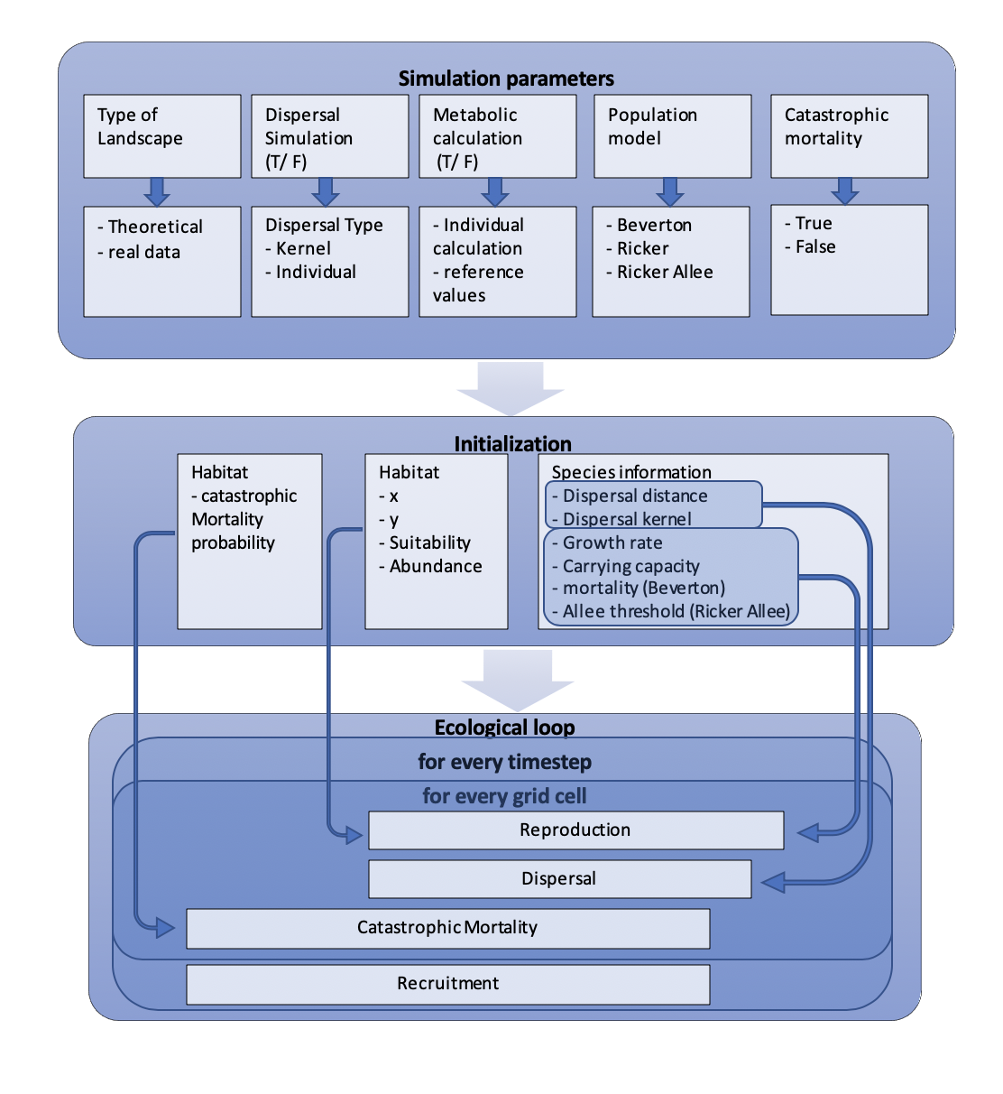

Fig. 1: Flowchart of the model processes

### Input

Model inputs (Tab.1) were a gridded theoretical fractal landscape (Chipperfield & Hovestadt, 2011); the mean annual temperature of the landscapes and the standard deviation of the temperature; the initial number of individuals (a random number between zero and the carrying capacity); the maximum dispersal distance; the standard deviations of the per capita growth rate, carrying capacity and mortality. The habitat characteristic of the species was the cut-off suitability, which determined the distribution and habitat suitability. The species-specific input parameters were the biomass, the standard deviation of the biomass, the optimum and tolerance temperature and the mean dispersal distance. For each species traits I defined ranges within which random values were drawn by a uniform distribution (Tab.2).

|  |  |  |  |
| --- | --- | --- | --- |
| Parameter | Value | Unit | Distribution |
| Landscape extend | 20 x 20 | Grid cells | - |
| Mean landscape temperature | 288,15 | K | lognormal |
| Standard deviation landscape temperature | 1,5 | - |  |
| Timesteps | 120 | years |  |
| Cut-off suitability | 0,7 | - | - |
| Maximum dispersal distance | 50 | Grid cells |  |
| Carrying capacity | 100 | g | lognormal |
| Activation energy | 0,65 | eV | - |
| Boltzmann’s constant | 8.6105 | - | - |
| Standard deviation growth rate | 0,01 | - | lognormal |
| Standard deviation  Carrying capacity | 0,01 | - | lognormal |
| Standard deviation  Mortality | 0,01 | - | beta distribution |
| Standard deviation  Allee threshold | 0,01 | - |  |

Tab. 1: Simulation model specifications and global parameters.

|  |  |  |  |
| --- | --- | --- | --- |
| Parameter | Ranges | Unit | Distribution |
| Dispersal distance | 0,01-0,5 | Grid cells | - |
| Biomass | 0,01 - 0,1 | g | lognormal |
| Standard deviation biomass | 0,000-0,002 | - | - |
| Optimum temperature | 273,15 - 303,15 | K | normal |
| Temperature tolerance | 1-20 | K | - |

Tab. 2: species-specific input parameters

### Initialization

Within the initialization the grid map and the species pool were read in. Each species received a species ID (from 1 to 20). The habitat suitability in the cell was determined by the optimal and tolerance temperature. Additionally, a dispersal kernel was initialized for each species (based on a negative exponential function). The dispersal distance and probability were not related to the biomass. For each species the abundance arrays were initialised. Additionally, arrays were initialized for the Biomass, the temperature, the habitat, the dispersal units and for the equation parameters (growth rate, carrying capacity, mortality and Allee threshold). The input values were distributed over the cells using different probability distributions (Tab.1).

### Stochasticity

To simulate populations as they occur in nature, stochasticity must be taken into account. Therefore, the framework allows different ways of applying stochasticity. First, during initialization, the initial number of individuals was randomly chosen by a uniform distribution between zero and the carrying capacity to avoid unrealistic values. To simulate fluctuations within the species biomass, a lognormal distribution was used for each cell and time step the standard deviation for (Tab.2). In addition, each equation parameter could be either stochastically distributed or deterministically. Two ways of applying stochasticity into the equation parameters were provided. First, stochasticity only occurs in the initial event. The parameter is then stochastically distributed for the first timestep, this stochastically distributed parameter value is then used for further calculations. Secondly, the parameter is stochastically distributed in each time step and in each grid cell. For both options a lognormal distribution for the growth rate and the carrying capacity was implemented (Tab. 1). In addition, stochasticity was included in the carrying capacity by its calculation over the lognormally distributed biomass. I used a lognormal distribution, since its range is from zero to infinity. While the range of a normal distribution extends from minus infinity to infinity. Within the Beverton-Holt model, mortality as a probability, was distributed through a beta distribution. In this matter I incorporated a function to calculate the shape value for the beta distribution (Supplementary eq.3). For the Allee threshold I used a normal distribution because negative values occur within the Allee threshold. Demographic heterogeneity was simulated by a Poisson distribution of the calculated number of individuals in each time step. Furthermore, demographic heterogeneity was simulated by stochasticity in Beverton deaths through a binomial distribution (eq. 1). This demographic heterogeneity occurs always and should therefore always be considered. Furthermore, I implemented demographic stochasticity through the lognormal distributed individual biomass of the species. Environmental stochasticity was implemented through a normal distribution in the temperature of the landscapes (white noise). The user could choose which parameters should be stochastic or deterministic. However, to simulate populations that are as realistic as possible, stochasticity should be taken into account. Besides I incorporated the parameters in a way that they can optionally follow metabolic restrictions (eq. 5 and eq.6). Within the reproduction function, different stochastic scenarios of the parameters and different population models could then be chosen in the simulation call.

### Reproduction

I considered species that propagates in discrete time steps. Many approaches start from a deterministic skeleton to which noise terms can be added (Melbourne & Hastings, 2008). To investigate the extinction risk, I implemented different population models. The number of offspring produced by the species in the cell was calculated for each grid cell according to the Beverton-Holt model (eq. 2) (Beverton & Holt, 1957). In the Beverton-Holt model it is assumed that mortality is composed of a density independent effect and a density dependent effect with respect to the juvenile population itself. I simulated mortality in a separate function therefore, I created a mortality function (eq.1).

$Bevertondeaths= \sum{rbinom(N,1,m)}$ (1)

Where *N* is the number of individuals and *m* is the mean mortality probability. The number of individuals was then calculated through excluding the dying individuals and adding the new-born individuals to the abundance. In this matter I subtracted the number of individuals that died, from the abundance and added the calculated the new-born individuals.

$N_{t+1}=N-Bevertondeaths+\frac{R*N}{1*N+\frac{R-1}{K}}$ (2)

Where *Nt* is the population size in individuals at time *t*, *R* (year-1) is the growth rate of the species in the cell, *K* is the carrying capacity (in individuals). *R*, *K* and *m* were calculated through the MTE (eq.5 and eq.6). In addition, I implemented the Ricker model (eq.3) for populations with overcompensating dynamics. Here, the density dependent effect is more related to the abundance than to the juvenile population.

$N_{t+1}=N_{t}∙e^{R∙\frac{1-N}{K}}$ (3)

Besides, I incorporated Allee effects into the Ricker model to simulate populations that have to assume a certain minimum size (eq.4).

$N_{t+1}=N_{t}*e^{R*\frac{4*K-N_{t}*N_{t}-C}{{\left(K-C\right)}^{2}}}$ (4)

Where *C* is the Allee threshold.

In the main methodical approach, I implemented the population models mentioned above in RStudio. In the simulation call it then can be decided which population model should be used for further calculations.

### Metabolic equation

To further study the influence of global warming on population extinction, I used the Metabolic Theory of Ecology (eq. 5 and eq.6). Demographic rates of species in a cell followed the metabolic theory (Brown *et al.,* 2004):

$Rate=b_{0}M^{-1/4}e^{-E/kT}$ (5)

where *Rate* is the particular parameter (growth rate or mortality) calculated through the MTE, *b0* is the proportionality constant of the particular parameter, *M* the biomass of the species (in g), *E* the activation energy (0.65 eV), *k* the Boltzmann constant (8,610-5) and *T* the temperature in Kelvin. Proportionality constants vary between taxa and between regions (Brown *et al*., 2004). The calculation of values for the constants is explained in the Supplementary Materials. When the carrying capacity and Allee followed the metabolic theory (Brown *et al.,* 2004):

$I=b_{0}M^{-3/4}e^{-E/kT}$ (6)

Where *I* is either the carrying capacity or the Allee threshold. Through the van’t Hoff-Arrhenius equation (eq. 6) the dependence of physiological rates on temperature is described (Laidler, 1984).

$e^{-\frac{E}{k*T}}$ (7)

This equation has its origin in statistical thermodynamics, where the behaviour of a system containing a very large number of a single type of molecule is predicted from statistical considerations of the behaviour of individual molecules.

### Catastrophic mortality function

Environmental stochasticity can be simulated through random catastrophic events. The probability of catastrophic mortality is calculated by a normal distribution within the initialization function. The distributed mortality probability is then used for each cell and timestep in the catastrophic mortality function. Within the catastrophic mortality function, the mortality probability is used to calculate the abundance in a cell after a catastrophic event using a binomial distribution (eq. 8).

$N_{t+1}=N_{t}-\sum{rbinom(N,1,mortality)}$ (8)

Where *mortality* is the probability of catastrophic extinction.

## Experimental design

To address the posed questions 1) how different global warming scenarios affects the extinction probability of species under a metabolic metapopulation framework and 2) how the extinction risk varies with species-specific traits associated with the metabolic constraints, I run a simulation for metapopulation dynamics with explicit local demographic dynamics under four different scenarios of global warming (Tab. 3). Here, the local population dynamics followed the Beverton-Holt population model. For the experiments I generated a data frame of 20 random species, in which the parameters of each species were calculated through a uniform distribution (Tab.2). I estimated the extinction risks across the entire metapopulation range for theoretical fractal landscapes. This type of landscape is realistic and neutral, which provide generalization of the findings (e.g. Cabral *et al*., 2011). Therefore, I created 20 theoretical fractal landscapes (Chipperfield & Hovestadt, 2011); as replicates (Fig.2 and Supplementary Fig.1). This is since in simulations that include stochasticity, a few replicates are necessary to obtain reasonable results. I run various climate change scenarios (Tab.3). In this regard four different climate change scenarios were considered (Tab.3). Assuming that the population has reached equilibrium after 20 timesteps. An increase in temperature for each timestep after the first 20 timesteps was included. In total I run 120 timesteps per simulation. For each calculation all parameters were stochastically distributed. Additionally, the parameters were always calculated through the MTE. In the experiment, I didn’t consider catastrophic mortality. The abundance was recorded for each time step and saved in a matrix (Supplementary Tab. X).

|  |  |
| --- | --- |
| Climate change scenario | Increase in temperature per time step (K year -1) |
| Scenario 1 | 0,00 |
| Scenario 2 | 0,02 |
| Scenario 3 | 0,04 |
| Scenario 4 | 0,06 |

Tab. 3: Climate change scenarios. Each scenario was simulated for each species in your species pools, in 20 different fractal landscapes as replicates.

Temp. [K]

Temp. [K]

Temp. [K]

Temp. [K]

Temp. [K]

Temp. [K]

Temp. [K]

Temp. [K]

Fig. 2: Theoretical Landscape 1 including Temperature with white noise, a) after one timestep; b) after ten timesteps and c) after 20 timesteps. Including white noise and increasing temperature for Scenario 4 after d) 40 timesteps; e) after 60 timesteps; f) after 80 timesteps; g) after 100 timesteps and h) after 120 timesteps. Climate change was incorporated after 20 timesteps. Ylength and Xlength are 20 grid cells and the colour gradient represent the temperature in Kelvin.

## Analyses

The abundance output was used to calculate the extinction risk for the four different climate change scenarios of the species. For this purpose, a second matrix was provided in which the extinction risk for each scenario and species ID was saved. To calculate the extinction risk, I summarized the number of landscapes (replicates) where the population was extinct in the last time step. The sum of the extinct populations was then divided by the number of total replicates (Supplementary Tab. X). The study questions were answered with several analyses. In this regard, I used the matrix containing the calculated abundances and the matrix including the calculated extinction risk of the different climate change scenarios and species traits (Supplementary Tab.X and Supplementary Tab. X). In order to investigate the risk of extinction depending on different climate change scenarios under a metapopulation metabolic framework, the difference between the second, third and fourth scenario to scenario 1 (which doesn´t take global warming into account) was visualized. For this purpose, the mean abundances in the last time step over the landscapes were calculated. The mean abundances of the second, third and fourth scenario were subtracted from the mean abundance of the first scenario which doesn´t consider an increase in temperature. The differences in the mean abundances of the scenarios were then plotted as a function of the species traits biomass and temperature (Fig.3). As the influence of biomass and optimum temperature is most interesting, considering the metabolic component and its influence on extinction risk, I focused on biomass and optimum temperature. From these plots those species could be determined which showed a difference in the mean abundance to the first scenario (Tab. 5). In the sense that they would probably become extinct after a longer period of time due to global warming. After those species were discovered, the abundance of those species was plotted over time to determine if the species was expected to become extinct after a longer period of time (Fig.4). To answer explicitly the second study questions, if the extinction risk varies with species traits associated with the metabolic constraints (mass and temperature niche traits) I created heatmaps for the extinction risk as functions of the different species traits for the four climate change scenarios (Fig.5). Based on the heatmaps, those species were identified which became extinct in each scenario, i.e. which could not form stable populations under the given environmental conditions. In addition, species were determined that were at higher risk of extinction due to global warming. Furthermore, species were identified which were stable in both climate change scenarios (Tab. 4). Additionally, it was determined which species showed a shift in abundance under different climate change scenarios as functions of species traits for the climate change scenarios (Fig.6).

# Results

Figure 3 shows how different rates of climate change affects species abundances and in this regard species extinction risk. It is apparent that different pastes of climate change have differing impacts on the abundance and extinction risk of species. It was determined that the species with ID1, ID2, ID11 and ID12 showed a positive difference for the abundance of the scenarios compared to scenario 1 (Fig.3a and 3c). As the mean abundances of the scenarios were subtracted from the mean abundance of scenario 1, the abundance is lower for scenarios with climate change compared to scenario 1. Whereas the species with ID3, ID5, ID8, ID13, ID15 and ID17 showed a negative difference for the abundance of the scenarios compared to scenario 1 (Fig.3a and 3c). Which implements that the abundance of the scenarios is higher compared to scenario 1. The remaining species showed no major difference in their mean abundance. Species which are threatened by climate change (Tab.5) are often able to maintain rather high abundance rates throughout the period of climate change if the climate changes slowly (Fig.4). However, if the climate changes more rapidly, the abundance of this species will decrease, until extinction becomes more likely. In Fig. 4 it appears that those species are able to maintain a high rate of abundance throughout the period of climate change if climate change occurs at a slower pace (scenario2). In the case of more rapid climate change, the species survives the period of climate change, but its abundance is lower than in a period of climatic stability (scenario3). In the climate change scenario with the most rapid temperature increase, the species cannot adapt fast enough and eventually become extinct (scenario4, Fig.4, Fig. 5 and Fig.6).

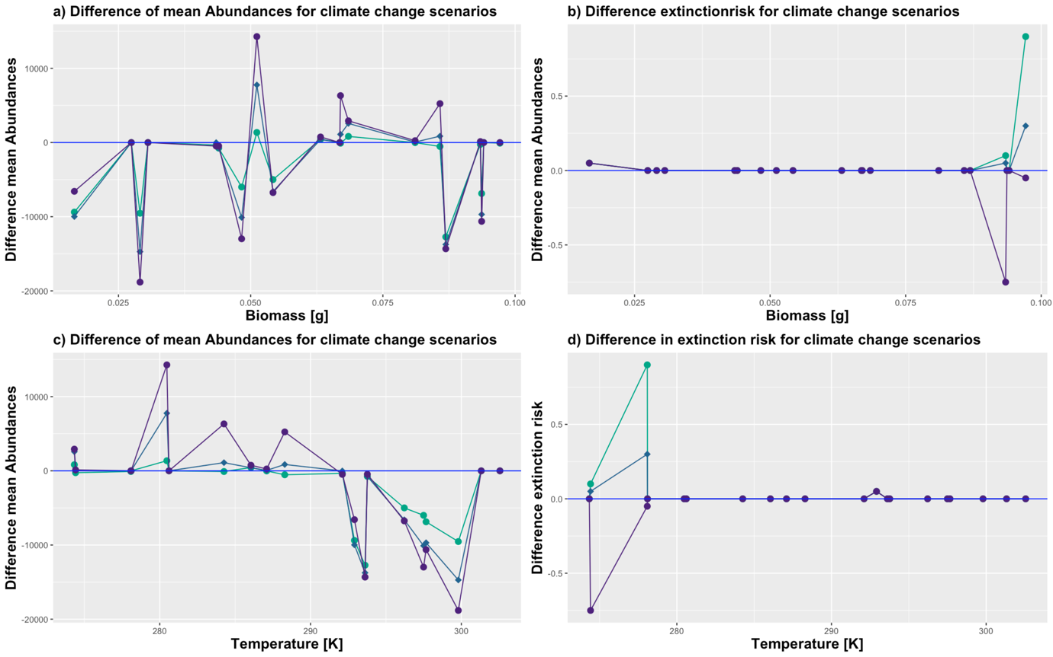

**ID**

**4**

**ID**

**8**

**ID**

**9**

**ID**

**11**

**ID**

**14**

**ID**

**18**

**ID**

**17**

**ID**

**20**

**ID**

**15**

**ID**

**16**

**ID**

**13**

**ID**

**19**

**ID**

**6**

**ID**

**3**

**ID**

**2**

**ID**

**10**

**ID**

**1**

**ID**

**5**

**ID**

**7**

**ID**

**12**

**ID**

**4**

**ID**

**8**

**ID**

**9**

**ID**

**11**

**ID**

**14**

**ID**

**18**

**ID**

**17**

**ID**

**20**

**ID**

**15**

**ID**

**16**

**ID**

**13**

**ID**

**19**

**ID**

**6**

**ID**

**3**

**ID**

**2**

**ID**

**10**

**ID**

**1**

**ID**

**5**

**ID**

**7**

**ID**

**12**

**ID**

**4**

**ID**

**7**

**ID**

**8**

**ID**

**9**

**ID**

**11**

**ID**

**12**

**ID**

**18**

**ID**

**17**

**ID**

**20**

**ID**

**15**

**ID**

**16**

**ID**

**13**

**ID**

**19**

**ID**

**6**

**ID**

**3**

**ID**

**2**

**ID**

**1**

**ID**

**5**

**ID**

**10**

**ID**

**14**

**ID**

**4**

**ID**

**7**

**ID**

**8**

**ID**

**9**

**ID**

**11**

**ID**

**12**

**ID**

**18**

**ID**

**17**

**ID**

**20**

**ID**

**15**

**ID**

**16**

**ID**

**13**

**ID**

**19**

**ID**

**6**

**ID**

**3**

**ID**

**2**

**ID**

**1**

**ID**

**5**

**ID**

**10**

**ID**

**14**

**Scenario 1 (+0,00 K) Scenario 3 (+0,04 K)**

**Scenario 2 (+0,02 K) Scenario 4 (+0,06K)**

**Baseline (scenario 1 +0,00K)**

Fig.3: Differences of the mean Abundance for the last timestep (of all landscapes) for the different climate change scenarios as a function of a) biomass [g] and c) optimum temperature [K]. Difference in the extinction risk for the two climate change scenarios as a function of b) biomass [g] and c) optimum temperature [K].

The exact way in which species reacts to different rates of climate change varies from species to species and depends on the species-specific traits i.e. its biomass and its optimum temperature. Thereby it appears reasonable that specialist’s species show an increased extinction risk under climate change scenarios even at slower rates of climate change. Concerning the second study question, how extinction risk depends on species-specific traits, figure 3 showes that he difference in abundances doesn´t show a clear pattern in relation to biomass (Fig. 3a). However, the difference in abundance of the scenarios differs as a function of optimum temperature. For lower optimum temperatures the difference is positive, following a decreasing abundance under climate change scenarios. For higher optimum temperatures the difference to the scenario without climate change becomes negative, indicating an increase in abundance under climate change (Fig. 3c). Which is reasonable as the environment temperature is approaching the optimum temperature of those species due to climate change.

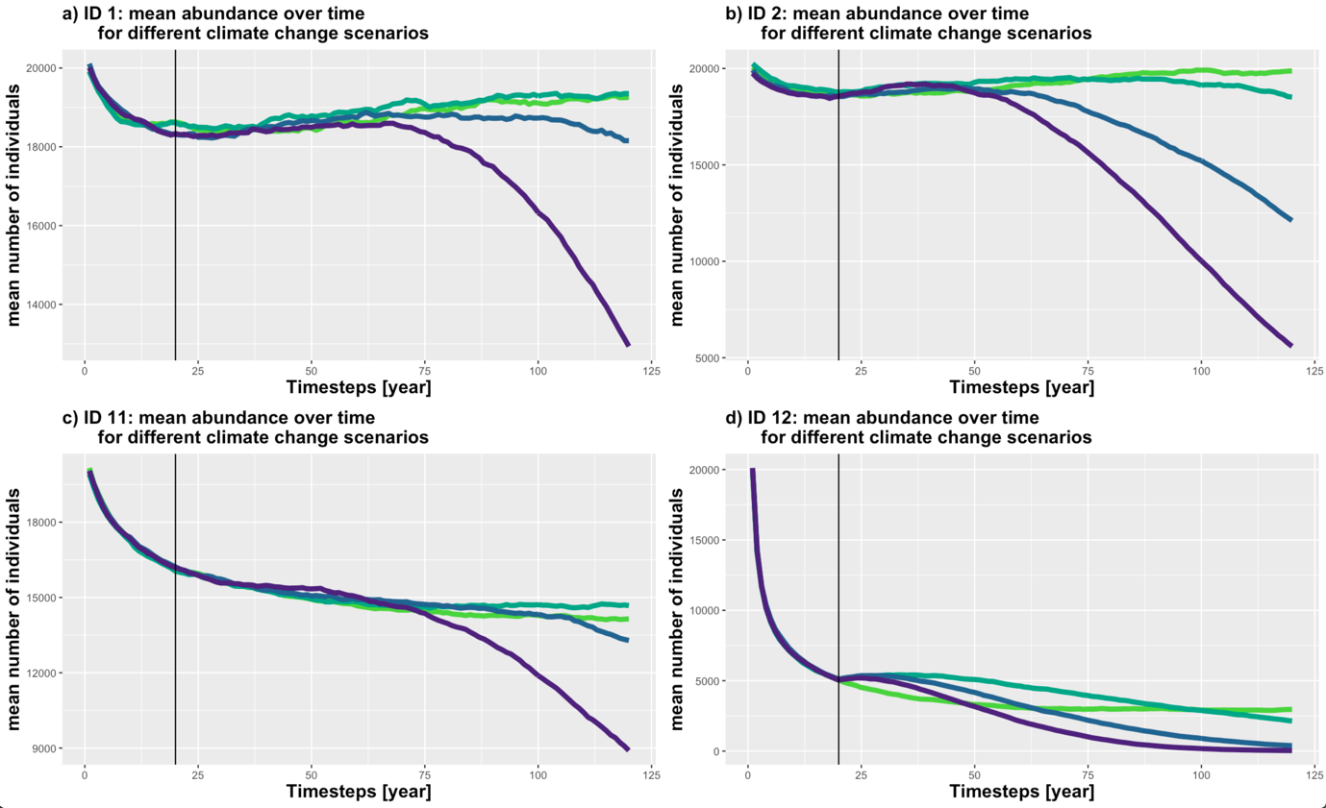

**Scenario 1 (+0,00 K) Scenario 3 (+0,04 K)**

**Scenario 2 (+0,02 K) Scenario 4 (+0,06K)**

Fig.4: Species with a decreasing abundance due to global warming. Mean abundance (of the different landscape simulations) over time for a) ID1; b) ID 2; c) ID 11 and d) ID 12. Global warming was included after 20 timesteps, which is illustrated by the black line.

Under any climate change scenarios, the species with ID 9, 16, 18 and 20 species were not able to form stable populations. While the species with ID7 and ID 19 showed a variation in the extinction risk under the different climate change scenarios. However, most species appear to form stable populations under all climate change scenarios (Fig.5 and Tab.4). However, considering the mean abundance of species, it appears that the abundance of some species changes with different climate change scenarios (Fig. 6 and Table 5), even if their extinction risk remains the same (Fig. 5 and Table 4). According to Figure 5 and Figure 6, species with marginal values for biomass and optimal temperatures are generally more threatened by extinction (Tab.4 and Tab.5). However, this effect appears greater for the optimum temperature. While an increased extinction risk under climate change occurs in species with high biomass and low temperature (Tab.4). Species whose abundance decreases under climate change had similar species-specific traits (Tab.5). While species whose abundances increased and whose extinction risk did not increase under climate change were characterized by a lower biomass and a high optimal temperature (Tab.4 and Tab.5).

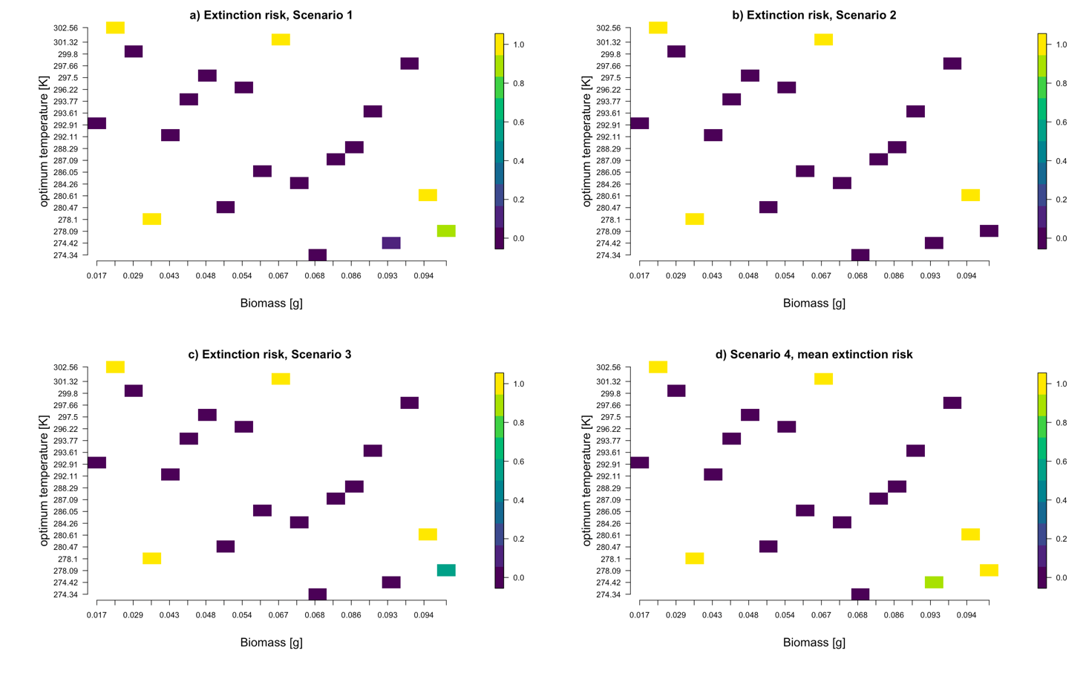

**ID**

**4**

**ID**

**7**

**ID**

**8**

**ID**

**9**

**ID**

**11**

**ID**

**14**

**ID**

**12**

**ID**

**18**

**ID**

**17**

**ID**

**20**

**ID**

**15**

**ID**

**16**

**ID**

**13**

**ID**

**19**

**ID**

**6**

**ID**

**3**

**ID**

**2**

**ID**

**10**

**ID**

**1**

**ID**

**5**

**ID**

**4**

**ID**

**7**

**ID**

**8**

**ID**

**9**

**ID**

**11**

**ID**

**14**

**ID**

**12**

**ID**

**18**

**ID**

**17**

**ID**

**20**

**ID**

**15**

**ID**

**16**

**ID**

**13**

**ID**

**19**

**ID**

**6**

**ID**

**3**

**ID**

**2**

**ID**

**10**

**ID**

**1**

**ID**

**5**

**ID**

**4**

**ID**

**7**

**ID**

**8**

**ID**

**9**

**ID**

**11**

**ID**

**14**

**ID**

**12**

**ID**

**18**

**ID**

**17**

**ID**

**20**

**ID**

**15**

**ID**

**16**

**ID**

**13**

**ID**

**19**

**ID**

**6**

**ID**

**3**

**ID**

**2**

**ID**

**10**

**ID**

**1**

**ID**

**5**

**ID**

**4**

**ID**

**7**

**ID**

**8**

**ID**

**9**

**ID**

**11**

**ID**

**14**

**ID**

**12**

**ID**

**18**

**ID**

**17**

**ID**

**20**

**ID**

**15**

**ID**

**16**

**ID**

**13**

**ID**

**19**

**ID**

**6**

**ID**

**3**

**ID**

**2**

**ID**

**10**

**ID**

**1**

**ID**

**5**

**Extinction risk**

**Extinction risk**

**Extinction risk**

**Extinction risk**

Fig. 5: Heatmap extinction risk for the different species IDs as a function of biomass and optimum temperature for a) the first scenario (+0,00 K per year); b) the second scenario (+0,02 K per year); c) the third scenario (+0,04 K per year) and d) fourth scenario (+0,06 K per year).

|  |  |  |  |  |  |  |
| --- | --- | --- | --- | --- | --- | --- |
| Extinction risk trends under global warming | Species ID | Biomass [g] | Standard deviation Biomass [g] | Optimum temperature [K] | Temperature tolerance [K] | Dispersal distance [grid cell] |
| Instable populations | 9  16  18  20 | 0,09407  0,02743  0,06685  0,03058 | 0,00090  0,00198  0,00151  0,00184 | 280,61  302,56  301,32  278,10 | 3,33  5,71  4,02  2,66 | 0,4635  0,2061  0,1714  0,4181 |
| Increasing extinction risk | 7  19 | 0,09344  0,09713 | 0,00021  0,00056 | 274,42  278,09 | 14,44  8,50 | 0,0372  0,2314 |
| No change in extinction risk | 1  2  3  4  5  6  8  10  11  12  13  14  15  17 | 0,06699  0,05117  0,04829  0,08109  0,08689  0,04348  0,09368  0,06321  0,08580  0,06849  0,01666  0,04395  0,02908  0,0542 | 0,00049  0,00098  0,00124  0,00166  0,00048  0,00180  0,00003  0,00190  0,00048  0,00016  0,00162  0,00141  0,00122  0,00014 | 284,26  280,47  297,50  287,09  293,61  292,11  297,66  286,05  288,29  274,34  292,91  293,77  299,80  296,22 | 15,07  16,65  11,19  19,61  9,15  14,66  14,21  16,63  10,09  18,42  4,33  16,15  13,28  14,96 | 0,3999  0,3798  0,3769  0,4322  0,2008  0,3602  0,3660  0,1859  0,4737  0,3811  0,1567  0,1887  0,2919  0,4806 |

Tab.4: Extinction risk trends under global warming for different species IDs.

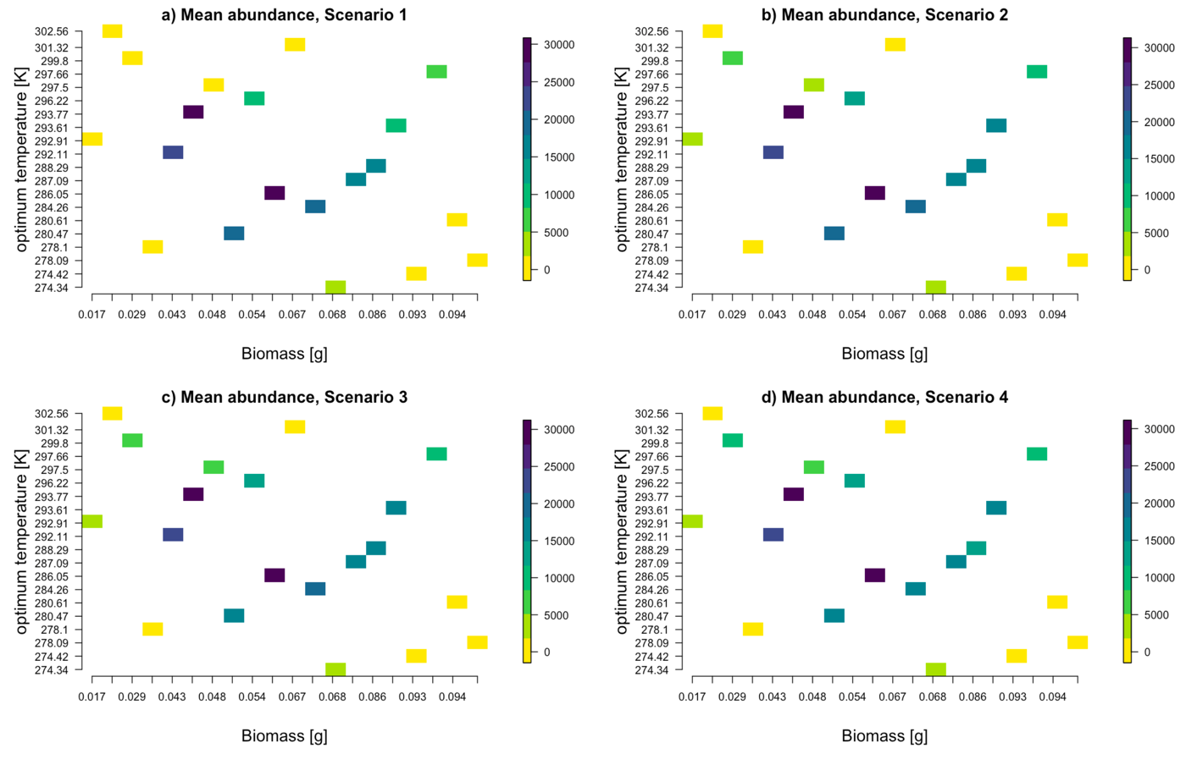

**ID**

**4**

**ID**

**7**

**ID**

**8**

**ID**

**9**

**ID**

**11**

**ID**

**14**

**ID**

**12**

**ID**

**18**

**ID**

**17**

**ID**

**20**

**ID**

**15**

**ID**

**16**

**ID**

**13**

**ID**

**19**

**ID**

**6**

**ID**

**3**

**ID**

**2**

**ID**

**10**

**ID**

**1**

**ID**

**5**

**ID**

**4**

**ID**

**7**

**ID**

**8**

**ID**

**9**

**ID**

**11**

**ID**

**14**

**ID**

**12**

**ID**

**18**

**ID**

**17**

**ID**

**20**

**ID**

**15**

**ID**

**16**

**ID**

**13**

**ID**

**19**

**ID**

**6**

**ID**

**3**

**ID**

**2**

**ID**

**10**

**ID**

**1**

**ID**

**5**

**ID**

**4**

**ID**

**7**

**ID**

**8**

**ID**

**9**

**ID**

**11**

**ID**

**14**

**ID**

**12**

**ID**

**18**

**ID**

**17**

**ID**

**20**

**ID**

**15**

**ID**

**16**

**ID**

**13**

**ID**

**19**

**ID**

**6**

**ID**

**3**

**ID**

**2**

**ID**

**10**

**ID**

**1**

**ID**

**5**

**ID**

**4**

**ID**

**7**

**ID**

**8**

**ID**

**9**

**ID**

**11**

**ID**

**14**

**ID**

**12**

**ID**

**18**

**ID**

**17**

**ID**

**20**

**ID**

**15**

**ID**

**16**

**ID**

**13**

**ID**

**19**

**ID**

**6**

**ID**

**3**

**ID**

**2**

**ID**

**10**

**ID**

**1**

**ID**

**5**

**Mean abundance**

**Mean abundance**

**Mean abundance**

**Mean abundance**

Fig. 6: Heatmap mean abundances for the different species IDs as a function of biomass and optimum temperature for a) the first scenario (+0,00 K per year); b) the second scenario (+0,02 K per year); c) the third scenario (+0,04 K per year) and d) fourth scenario (+0,06 K per year).

|  |  |  |  |  |  |  |
| --- | --- | --- | --- | --- | --- | --- |
| Abundance trends under global warming | Species ID | Biomass [g] | Standard deviation Biomass [g] | Optimum temperature [K] | Temperature tolerance [K] | Dispersal distance [grid cell] |
| Instable populations | 9  16  18  20 | 0,09408  0,02743  0,06685  0,03058 | 0,00090  0,00198  0,00151  0,00184 | 280,61  302,56  301,32  278,10 | 3,33  5,71  4,02  2,66 | 0,4635  0,2061  0,1714  0,4181 |
| Decreasing abundance | 1  2  11  12  19 | 0,06699  0,05117  0,08580  0,06849  0,09713 | 0,00049  0,00098  0,00048  0,00016  0,00056 | 284,26  280,47  288,29  274,34  278,09 | 15,07  16,65  10,09  18,42  8,50 | 0,3999  0,3798  0,4737  0,3811  0,2314 |
| No change | 4  6  7  10 | 0,08109  0,04348  0,09344  0,06321 | 0,00166  0,00180  0,00021  0,00190 | 287,09  292,11  274,42  286,05 | 19,61  14,66  14,44  16,63 | 0,4322  0,3602  0,0372  0,1859 |
| Increasing abundance | 3  5  8  13  14  15  17 | 0,04829  0,08690  0,09367  0,01666  0,04395  0,02908  0,05423 | 0,00124  0,00048  0,00003  0,00162  0,00141  0,00122  0,00014 | 297,50  293,61  297,66  292,91  293,77  299,80  296,22 | 11,19  9,15  14,21  4,33  16,15  13,28  14,96 | 0,3769  0,2008  0,3660  0,1567  0,1887  0,2919  0,4806 |

Tab.5: Abundance trends under scenarios of global warming for different species IDs.

# Discussion

Concerning the first study question on how different global warming scenarios affect the likelihood of species extinction under a metabolic metapopulation framework it was observed that extinction becomes more likely due to decreasing abundances when the climate changes more rapidly (Fig.4). This was expected, since species are unable to adapt fast enough to the changing environment in the event of rapid climate changes. This effect was expected, since the stability and extinction of metapopulations are strongly influenced by the rate at which the landscape changes under current scenarios of global warming (Keymer *et al*., 2000). Similar results were also described by Travis (2003). The results show that species threatened by global warming are more likely to become extinct if the temperature changes occur rapidly. This is an important observation if the extinction of species due to climate change shall be prevented.

Regarding the second question whether the extinction risk depends on species-specific traits, associated with the metabolic constraints (mass and temperature niche traits) it occurs that the extinction risk depends strongly on species traits i.e. biomass, optimum temperature, temperature tolerance and dispersal. Concerning the temperature tolerance, species with a low temperature tolerance couldn´t form stable populations under all climate change scenarios. This can be deduced from the fact that a white noise is included in temperature. These small fluctuations in temperature can already be responsible for the death of species with low temperature tolerances. However, this effect could overshadow the influence of biomass and temperature on species extinction risk. Species that showed an increased risk of extinction under climate change scenarios often had a high biomass and a low optimum temperature. This was to be expected since specialists, especially those with rather low temperature tolerance and low dispersal ranges, are most threatened by climate change because the environmental temperature is diverging further and further away from their optimum temperature under climate change. It occurs that species containing a high biomass are at higher extinction risk (Fig.3, Fig.5 and Tab.4). Further, species whose population abundance decreased with global warming had also a low optimum temperature and a rather high biomass (Fig.6 and Tab.5). Under a metabolic aspect, this pattern is was expected since large organisms require more resources than small ones, consume them over a longer time period and because both, total resource demand and flux rates increase at higher temperatures (Brown *et al.,* 2004).

Whereas the activity of small individuals is higher in warm environments than in cold ones (Brown *et al.,* 2004). Which explains the increasing abundances for small individuals under climate change. Additional species which abundances increased under global warming contained a high optimum temperature. This was also expected because environmental conditions under climate change approached the optimum temperature for those species. Moreover, it would have been expected that low dispersal ability will also contribute to a higher extinction risk since the extinction risk is generally minimized by long-distance dispersal (Kallimanis *et al.,* 2005). However, this effect could not be observed. This could be because in this study the extinction risk was investigated for hypothetical, random species. Therefore, the effect of certain species-specific traits could be overlaid by other characteristics.

## Limitations and Perspectives

The role of individual species-specific traits could not be determined with certainty, as their impact on the extinction risk could be overshadowed by other species-specific traits. Therefore, to investigate the role of those traits on the extinction risk of species under a metabolic framework it would be crucial to run a range filling simulation that the extinction risk could be determined for every possible combination of species-specific traits. In this regard the dispersal distance should depend on the biomass. Nevertheless, trends in extinction risk under climate change scenarios for species-specific characteristics could be identified. Which is crucial for understanding the extinction risk of species under a metabolic framework. At this model and experiment, I used only hypothetical neutral landscapes and biological knowledge was assimilated by constraining the ranges of the species-specific parameter ranges, particularly for body mass and optimum temperature. Hence, further studies could attempt to use real-world landscapes and trait data for focus species. Therefore, empirical data for biomass, thermal niche traits, intraspecific heterogeneity, dispersal ability, would be needed. Nevertheless, my results already provide valuable insights into the trait combinations, and thus species, that will be particularly vulnerable to global warming. In this study the Beverton-Holt population model was used, further model development could go in the direction of implementing other models e.g. the Ricker population model (Ricker, 1954). Besides, Allee effects could be included (Allee, 1949). This is particularly relevant for organisms with a social structure. Here populations often have to assume a certain minimum size so that mating, courtship or hunting, is successful. To ensure the survival of a population, it is therefore important that it does not fall below a certain minimum population size. Other demographic processes, such as catastrophic mortality due to perturbations could also be considered in further studies. In addition, it would be interesting to calculate the number of occupied cells and number of potentially suitable cells besides the average abundance per cell and other stability variables.

Overall, the study shows how species with different species-specific traits react to different climate change scenarios under a metabolic framework. Within the context of this study, the simulation was only able to examine small ranges, however, it already reveals interesting trends. Based on this, a further study could be established containing larger and more landscapes as replicates and simulating them over a longer period of time. The benefit of this metabolic framework is that the effects of body size and temperature are combined in a single expression. This permits precise comparisons between organisms that differ not only in body size but also in their optimum temperature and therefore represents species in different taxonomic or functional groups or in different environments (Brown *et al.,* 2004).

# References

Allee, W.C., Emerson, A.E., Park, O. et al. (1949) *Principles of animal ecology*. W. B. Saunders, Philadelphia, PA.

Araújo, M.B. & Guisan, A (2006) Five (or so) challenges for species distribution modelling. *Journal of Biogeography*, **33**, 1677–1688.

Barnosky, A., Matzke, N., Tomiya, S., Wogan, G., Swartz, B., Quental, T., Marshall, C., McGuire, J., Lindsey, E., Maguire, K.C., Mersey, B. & Ferrer, E. (2011) Has the Earth’s Sixth Mass Extinction Already Arrived? *Nature*, **471**, 51-7.

Benton, T.G., Cameron T.C. & Grant, A. (2004) Population responses to perturbations: predictions and responses from laboratory mite populations. *Journal of Animal Ecology*, **73**, 983–995.

Beverton, R.J.H. & Holt, S.J. (1957) *On the dynamics of exploited fish populations*. Fishery Investigations Series II, 19. Her Majesty’s Stationary Office, London.

Boettiger, C. (2018) From noise to knowledge: how randomness generates novel phenomena and reveals information. *Ecology Letters*, **21**, 1255–1267.

Brown, J.H., Gillooly, J.F., Allen, A.P., Savage, V.M. & West, G.B. (2004) Toward a metabolic theory of ecology. *Ecology*, **85**, 1771–1789.

Cabral, J.S., Bond, W.J., Midgley, G.F., Rebelo, A.G., Thuiller, W. and Schurr, F.M., (2011) Effects of harvesting flowers from shrubs on the persistence and abundance of wild shrub populations at multiple spatial extents. *Conservation Biology*, **25**, 73-84.

Cabral, J.S. & Kreft, H. (2012) Linking ecological niche, community ecology and biogeography: Insights from a mechanistic niche model. *Journal of Biogeograph*y, **39**, 2212–2224.

Cabral, J.S., Wiegand, K. & Kreft, H., (2019) Interactions between ecological, evolutionary and environmental processes unveil complex dynamics of insular plant diversity. *Journal of Biogeography*, **46**, 1582-1597.

Cabral, J.S. & Schurr, F.M., (2010) Estimating demographic models for the range dynamics of plant species. *Global Ecology and Biogeography*, **19**, 85-97.

Chipperfield, J., Dytham & C., Hovestadt, T. (2011) An Updated Algorithm for the Generation of Neutral Landscapes by Spectral Synthesis. *PloS one*, **6**. e17040.

Downing, A. & Leibold, M. (2002) Ecosystem consequences of species richness and composition in pond food webs. *Nature*, **416,**837–841.

Dormann, C.F., Schymanski, S., Cabral, J.S., Chuine, I., Graham, C., Hartig, F., Kearney, M., Morin, X., Römermann, C., Schröder, B. & Singer, A. (2012) Correlation and process in species distribution models: bridging a dichotomy. *Journal of Biogeography*, **39**, 2119-2131.

Drake, J.M. & Lodge D.M. (2004) Effects of environmental variation on extinction and establishment. *Ecology Letters*, **7**, 26–30.

Engen, S., Lande R. & Saether B.E. (2002) The spatial scale of population fluctuations and quasi-extinction risk. *American Naturalist*, **160**, 439–451.

Eskola, H. & Geritz, S. (2007) On the Mechanistic Derivation of Various Discrete-Time Population Models. *Bulletin of mathematical biology*, **69**, 329-46.

Fagan, W.F., Meir E., Prendergast J., Folarin A., & Karieva P. (2001) Characterizing population vulnerability for 758 species. *Ecology Letters*, **4**, 132–138.

Folland, C., Karl, T.R. & Christy, J.R. (2001) Climate Change 2001: The Scientific Basis. Contribution of Working Group I to the Third Assessment Report of the Intergovernmental Panel on Climate Change. *Observed climate variability and change*, 99-181.

Gamarra, J. (2005) Metapopulations in multifractal landscapes: On the role of spatial aggregation. *Proceedings. Biological sciences / The Royal Society*, **272**, 1815-22.

García-Robledo, C., Erin K. Kuprewicz, C., Staines L., Erwin T.L. & Kress W.J. (2016) Limited tolerance by insects to high temperatures across tropical elevational gradients and the implications of global warming for extinction, *Proceedings of the National Academy of Sciences*, **113**, 680-685.

Guisan, A. & Thuiller, W. (2005) Predicting species distribution: offering more than simple habitat models. *Ecology Letters*, **8**, 993–1009.

Guisan, A. & Zimmermann, N.E. (2000) Predictive habitat distribution models in ecology. *Ecological Modelling*, **135**, 147–186.

Gilbert, L.E (1980) Food web organization and the conservation of neotropical diversity. *Conservation biology: an evolutionary ecological perspective*, 11-33.

Gotelli, N. (1991) Metapopulation Models: The Rescue Effect, the Propagule Rain, and the Core-Satellite Hypothesis. *American Naturalist - AMER NATURALIST*, **138**, 768-776.

Grimm, V., Berger, U., Deangelis, D., Polhill, J., Giske, J. & Railsback, S. (2010) The ODD protocol: A review and first update. *Ecological Modelling*, **221**, 2760-2768.

Hanski, I. & Simberloff, D. (1997) The Metapopulation Approach, Its History, Conceptual Domain, and Application to Conservation. *Metapopulation Biology*, **1**, 5-26.

Hanski, I. (1997) Metapopulation Dynamics. *Nature*, **396**, 69-91.

Higgins, S.I., Nathan, R. & Cain, M.L. (2003) Are long-distance dispersal events in plants usually caused by nonstandard means of dispersal? *Ecology*, **84**, 1945–1956.

Holt, R.D. (2009) Bringing the Hutchinsonian niche into the 21st century: ecological and evolutionary perspectives. *Proceedings of the National Academy of Sciences USA*, **106**, 19659–19665.

Holt, R.D., Keitt, T.H., Lewis, M.A., Maurer, B.A. & Taper, M.L. (2005) Theoretical models of species’ borders: single species approaches. *Oikos*, **108**, 18–27.

IPCC, 2001: Climate Change (2001): The Scientific Basis. Contribution of Working Group I to the Third Assessment Report of the Intergovernmental Panel on Climate Change [Houghton, J.T., Y. Ding, D.J. Griggs, M. Noguer, P.J. van der Linden, X. Dai, K. Maskell, and C.A. Johnson (eds.)]. Cambridge University Press, Cambridge, United Kingdom and New York, NY, USA, 881pp.

Jamieson, M. A., Trowbridge, A. M., Raffa, K. F., & Lindroth, R. L. (2012) Consequences of climate warming and altered precipitation patterns for plant-insect and multitrophic interactions. *Plant physiology*, **160**, 1719-1727.

Kallimanis, A.S., Kunin, W.E., Halley, J.M. & Sgardelis, S.P., (2005) Metapopulation extinction risk under spatially autocorrelated disturbance. *Conservation Biology*, **19**, 534-546.

Keymer, J.E., Marquet, P.A., Velasco-Hernández, J.X. & Levin, S.A. (2000) Extinction thresholds and metapopulation persistence in dynamic landscapes. *The American Naturalist,* **156**, 478-494.

Kooijman, S. A. L. M., Sousa, T., Pecquerie, L., Van der Meer, J., & Jager, T. (2008) From food-dependent statistics to metabolic parameters, a practical guide to the use of dynamic energy budget theory. *Biological Reviews*, **83**, 533-552.

Laidler, K. J. (1984) The development of the Arrhenius equation. *Journal of Chemical Education*, **61**, 494.

Lande, R. (1993) Risks of population extinction from demographic and environmental stochasticity and random catastrophes. *Am. Nat*., **142**, 911–927.

Loarie, S.R., Duffy, P.B., Hamilton, H., Asner, G.P., Field, C.B. & Ackerly, D.D. (2009) The velocity of climate change. *Nature*, **462**, 1052–1055.

Melbourne, B. A., & Hastings A. (2008). Extinction risk depends strongly on factors contributing to stochasticity. *Nature*, **454**,100–103.

Munch, S. B., & Salinas, S. (2009) Latitudinal variation in lifespan within species is explained by the metabolic theory of ecology. *Proceedings of the National Academy of Sciences*, **106**, 13860-13864.

Nathan, R. (2006) Long-distance dispersal of plants. *Science*, **313**, 786–788.

National Research Council (2010) Advancing the Science of Climate Change. *The National Academies Press*.

Nentwig, W., Bacher, S. & Brandl, R. (2017) *Ökologie kompakt, Bachelor*. Spektrum Akademischer Verlag.

Pagel, J. & Schurr, F.M., (2012) Forecasting species ranges by statistical estimation of ecological niches and spatial population dynamics. *Global Ecology and Biogeography*, **21**, 293-304.

Paine, R. (1966) Food web complexity and species diversity. *Amer. Nat*., **100**, 65-7.

Parmesan, C. & Yohe, G. (2003) A globally coherent fingerprint of climate change impacts across natural systems*. Nature*, **421,** 37-42.

Ehrlich, P.R. & Daily, G.C. (1993) Population extinction and saving biodiversity. *Ambio*, **22**, 64-68.

Pearson, R.G. & Dawson, T.P. (2003) Predicting the impacts of climate change on the distribution of species: are bioclimate envelope models useful? *Global Ecology and Biogeography*, **12**, 361–371.

Pimm, S., Russell, G., Gittleman, J. & Brooks, T. (1995) The Future of Biodiversity. *Science*, **269**, 347-50.

Pounds, J.A., Fogden, M.L. P. & Campbell, J. H. (1999) Biological response to climate change on a tropical mountain. *Nature* **398,** 611-615.

Quinn, T. (2013) Population Dynamics. *In Wiley StatsRef: Statistics Reference Online*.

Ricker, W.E. (1954) Stock and Recruitment. *Journal of the Fisheries Research Board of Canada*, **11**, 559-623.

Ripa, J., & Heino, M. (1999) Linear analysis solves two problems in population dynamics: the route to extinction and extinctions in coloured environments. *Ecology Letters*, **2**, 219–222.

Root, T.L. *et al.* (2003) Fingerprints of global warming on wild animals and plants. *Nature* **421,** 57-60.

Scheffers, B., De Meester, L., Bridge, T., Hoffmann, A., Pandolfi, J., Corlett, R., Butchart, S., Pearce-Kelly, P., Kovacs, K., Dudgeon, D., Pacifici, M., Rondinini, C., Foden, W., Martin, T., Mora, C., Bickford, D. & Watson, J. (2016) The broad footprint of climate change from genes to biomes to people. *Science*. **354**. 7671-7671.

Schurr, F.M., Pagel, J., Cabral, J.S., Groeneveld, J., Bykova, O., O’Hara, R.B., Hartig, F., Kissling, W.D., Linder, H.P., Midgley, G.F. & Schröder, B., (2012) How to understand species’ niches and range dynamics: a demographic research agenda for biogeography. *Journal of Biogeography*, **39**, 2146-2162.

Seibold, S., Gossner, M.M., Simons, N.K., Blüthgen, N., Müller, J., Ambarlı, D., Ammer, C., Bauhus, J., Fischer, M., Habel, J.C. and Linsenmair, K.E. (2019) Arthropod decline in grasslands and forests is associated with landscape-level drivers. *Nature*, **574**, 671-674.

Shoemaker, L. G., Sullivan, L. L., Donohue, I., Cabral, J. S., Williams, R. J., Mayfield, M. M., Chase, J. M., Chu, C., Stanley Harpole, W., Huth, A. , HilleRisLambers, J. , James, A. R. M., Kraft, N. J. B., May, F., Muthukrishnan, R., Satterlee, S., Taubert, F., Wang, X., Wiegand, T., Yang, Q. & Abbott, K. C. (2020) Integrating the underlying structure of stochasticity into community ecology. *Ecology*, **101**.

Stearns, B. P & Stearns, S.C. (2000) *Watching, from the Edge of Extinction*. Yale University Press.

Stephens, P., Sutherland, W., & Freckleton, R. (1999) What Is the Allee Effect? *Oikos*, **87**, 185-190.

Svenning, J.C. & Skov, F. (2004) Limited filling of the potential range in European tree species. *Ecology Letters*, **7**, 565–573.

Taylor, P. (2004) *Extinctions in the History of Life*. Cambridge: Cambridge University Press.

Thomas, C., Cameron, A., Green, R., Bakkenes, M., Beaumont, L., Collingham, Y., Erasmus, B., Siqueira, M., Grainger, A., Hannah, L., Hughes, L. Huntley, B., Van Jaarsveld, A., Midgley, G., Miles, L., Ortega-Huerta, M., Peterson, A., Phillips, O. & Williams, S. (2004) Extinction risk from climate change. *Nature*, **427**, 145-8.

Travis, J.M.J. (2003) Climate change and habitat destruction: a deadly anthropogenic cocktail. Proceedings of the Royal Society of London. *Series B: Biological Sciences,* **270**, 467-473.

van der Meer, J. (2006) Metabolic theories in ecology. *Trends in ecology & evolution*, **21**, 136-140.

Vandermeer, J.H., Goldberg D.E. (2013) *Population ecology: first principles/ John H. Vandermeer and Deborah E. Goldberg*. Princeton University Press, Second Edition.

Zurell, D. & Thuiller, W., Pagel, J., Cabral, J.S., Münkemüller, T., Gravel, D., Dullinger, S. Normand, S., Schiffers, K., Moore, K. & Zimmermann, N. (2016) Benchmarking novel approaches for modelling species range dynamics. *Global change biology*, **22**, 2651-2664.

# Supplementary Material

***Theoretical Landscape***



Supplementary Fig.1: Theoretical Landscape 1 without temperature, with xlength = 20 and ylength = 20, where the yellow area shows suitable habitat, while the red area shows unsuitable habitat.

***Random species pool***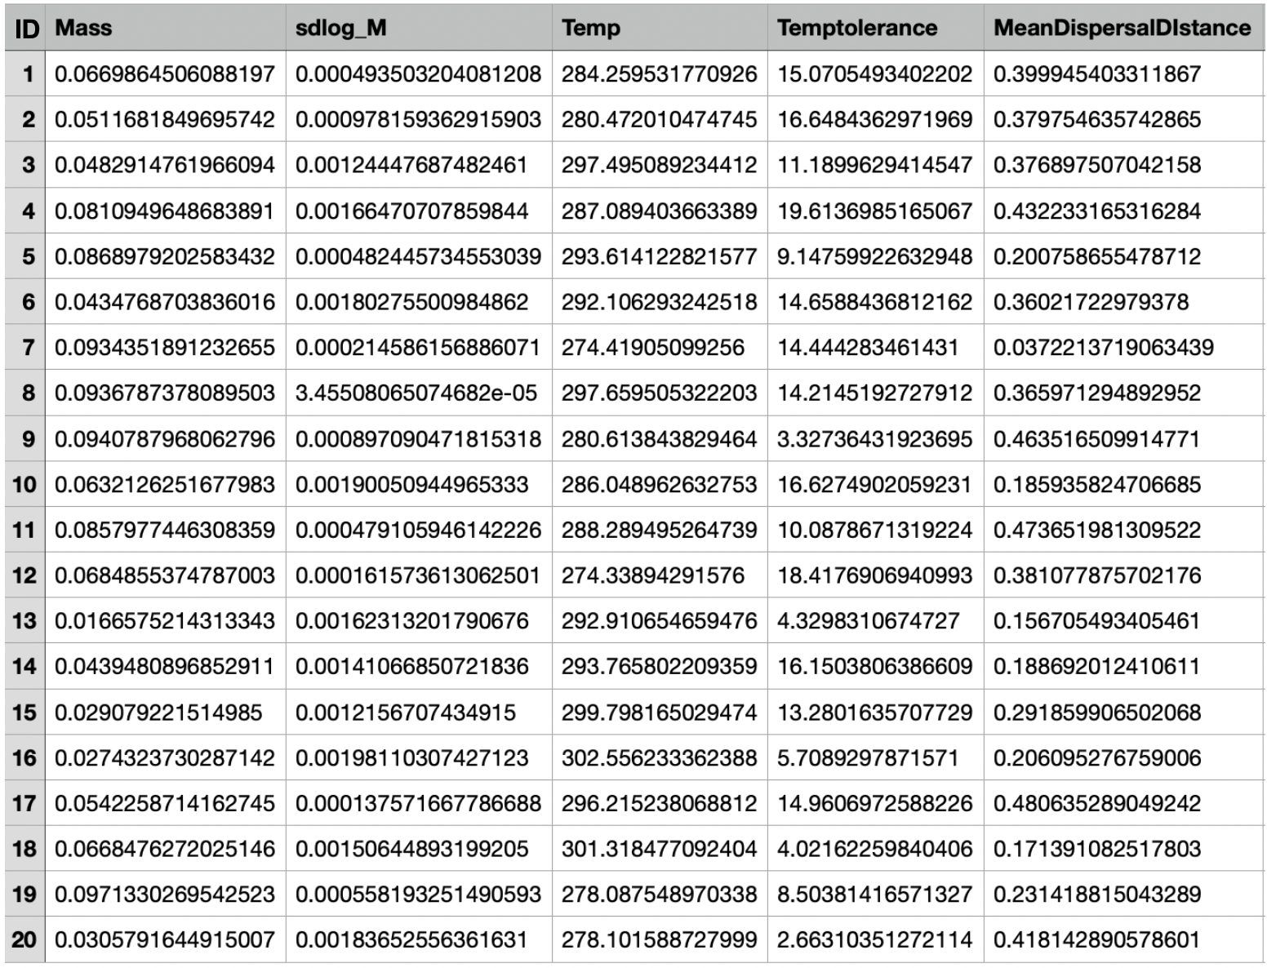

Supplementary Tab. 1: Random species pool

***Equation for parameter calibration***

$b_{0}=\frac{Rate}{M^{-1/4}e^{-E/kT}}$ (1)

where *b0* is the proportionality constant of the particular parameter, *Rate* is the particular parameter (growth rate or mortality) calculated through the MTE,  *M* the biomass of the species (in g), *E* the activation energy (0.65 eV), *k* the Boltzmann constant (8,610-5) and *T* the temperature in Kelvin.

$b_{0}=\frac{I}{M^{-3/4}e^{-E/kT}}$ (2)

*I* is the particular parameter (carrying capacity or the Allee threshold) calculated through the MTE

|  |  |  |  |
| --- | --- | --- | --- |
| *Rate/ I* | Mass for calibration | Temperature for calibration | Parameter constant |
| *R =* 1,2 [year-1] | 0,05 | 288,15 |  |
| *m* = 0,01 | 0,05 | 288,15 |  |
| *Carrying capacity* = 100 [g] | 0,05 | 288,15 |  |
| *Allee threshold= -*100 [g] | 0,05 | 288,15 |  |

Supplementary Tab.2: Parameter calibration

***Beta distribution***

$beta=\frac{alpha-(alpha∙m)}{m}$ (3)

Where *alpha* and *beta* are shape parameters and *m* the mean mortality probability. The beta distribution is a probability distribution defined on the interval [0, 1] The two positive shape parameters (*alpha* and *beta*) control the shape of the distribution.

# Eigenständigkeitserklärung

**Erklärung**

Hiermit erkläre ich an Eides statt, dass ich die Bachelorarbeit

*„* *The extinction of species as a result of global warming: how increased metabolic rates upscale to species extinction dynamics “*

selbständig angefertigt und keine anderen als die von mir angegebenen Quellen und Hilfsmittel benutzt habe.

Ich erkläre außerdem, dass diese Arbeit weder in gleicher oder anderer Form bereits in einem anderen Prüfungsverfahren vorgelegen hat.

Ich habe früher außer den mit dem Zulassungsgesuch urkundlich vorgelegten Graden keine weiteren akademischen Grade erworben oder zu erwerben versucht.

|  |  |
| --- | --- |
| Würzburg, den |  |
|  | Unterschrift  (Vor- und Zuname) |

1. https://www.r-project.org/